RIJO THOMAS  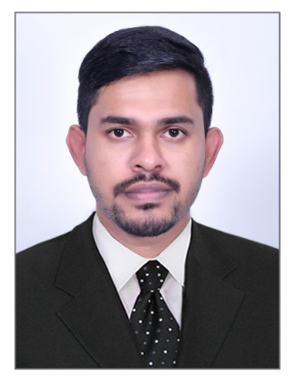  Present Location  Dubai , UAE  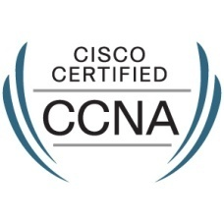  CISCO ID: CSCO12374909  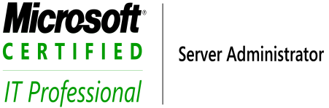  MS ID: 10408958  Personal Data  Mobile:+971 55 8918285  EMail:rijovettickal@hotmail.com  Passport No.:S7868125  Nationality: Indian  Date of Birth: 29/09/1986  Sex: Male  Operating System  - Windows XP  - Windows Server 2003  - Windows 7  Skills  - A+ (Hardware)  - N+ (Networking)  - CCNA,CCNP  - CISCO ROUTER AND SWITCH  - MCITP SERVER  Strength  - Punctual  - Efficient  - Energetic  - Hard working  - Sincere | CAREER OBJECTIVE  - To be an integral part of an industry which can provide me the right platform to do a challenging job; where I can use my strengths and my engineering prowess for the growth of the organization and also for my personal growth, learning and development..  SUMMARY OF EXPERIENCE  - Worked as IT Specialist at Genius Computer Technology LLC Jebel Ali Free Zone Dubai [March 2017 to June 2018]  - Worked as IT Support at TED Computer System LLC Dubai [May 2014 to August 2016]  - Worked as IT Support at HeadERP Solution PVT LTD [Aug 2010 to Nov 2013]  - Worked as Web Developer Trainee at Stylus Inc Bangalore.  [April 2010 to Aug 2010]  PROFESSIONAL SUMMARY  - Excellent communication and interpersonal skills with proven abilities in resolving complex Networking and software related  - Responsible for Network/Systems administration including Basic support with the goal of providing excellent system reliability, performance, high availability and overall optimized systems infrastructure.  EDUCATIONAL QUALIFICATION  - B.Tech in computer science and Engineering 2005- 2009  Kannur University  - Hardware and Network Engineering 2008  Gov. collage of Engineering Kannur  PROFESSIONAL CERTIFICATION  - Solid experience & knowledge in LAN/ WAN designing, implementing and supporting high bandwidth enterprise Cisco and Microsoft environment.  - Domain expertise in installing, Windows systems and network. Hands on experience with Hardware and Router configurations.  - Strong hands on experience in Windows 2008/2012/2016 server administration with Active directory  - Strong knowledge in configuring CISCO based routing e.g. RIP, EIGRP,  - Experience in Network controller configuration and NAS storage configuration.  Work Experience  GENIUS COMPUTER TECHNOLOGY LLC  Technical Advisor cum Logistics Coordinator  - IT Asset Management, RMA  - Total Wireless Solution Support  - GITEX presentation  - CCTV Configuration & Management  - New user creation and mail box backup in the exchange server 2007  - Access Point & Controller Configuration(outdoor & indoor and point to point for large scale )  - NAS Configuration for The Backup ,User Share Access, Troubleshooting  - NAS configuration To client, Laptop, Desktop, Routers, Switches, printers and scanners  - Installations, configurations and managing of Windows Desktops, laptops & software  - Troubleshooting printers, scanners and other peripherals  - Remote and end to end user support  - Printers Supporting (IP and Local)  - Respond quickly and efficiently to all incoming calls for information  - Ensure that all incoming emails are replied to in a prompt fashion and with pertinent information  - Preparation of document includes Delivery Note, sales order, LTI, LTO, GRV, CREDIT NOTE, Material issue using Orion.  TED COMPUTER SYSTEM (DUBAI)  Designation: IT System engineer  Maintenance IT Desktop Annual Maintenance Contract(AMC)  - Outlook mail configuration, backup & restoration & Maintain email backups.  - Resolved tenancy technical issues and monitored Office 365 systems.  - On site/telephonic/ remotely technical support to customer.  - Configuring and troubleshooting the local and network printers.  - Installing software, troubleshooting hardware & windows OS issues.  - Perform Laptop backup and restore.  On Network side  - Maintain LAN Networks.  - Identifying, diagnosing, and resolving network problems.  - Configuring and managing of Cisco Wireless controller.  - Configuring VPNs and managing remote users.  - Working on firewall to Creating Security Policies.  On Server side  - Installing, migration & Configuration of Server 2008&2012.  - Implementation and installation of Active Directory Services on windows 2008, 2012 & 2016 server.  - Creating & Deleting Domain user Accounts & configuring group policies.  Security Systems  - Have Certificate in DPS Systems Engineer for Security surveillance Systems (CCTV) From Dubai police Academy.  - Purchase and Configure CCTV equipment, software, DVR, NVR and peripherals utilizing different vendors.  - Configuration of Firewall devices like fort iGATE 100D  PROJECT EXPERIENCE  - The Address Hotel Dubai:- One Year Residence Engineer (Ref:Sujith Balan )  - Design lab FZE :- Two Months Residence Engineer (Dubai)  - REINTJES LLC (MERITIME CITY, DUBAI) :-AMC  - SPACE WELL LLC (INTERNET CITY, DUBAI):-AMC  - Emkay LLC(Dubai):-AMC  - CRANLEIGH INTERNATIOAL SCHOOL (ABU DHABI) :-  6 months Desktop Support  - Damac Hotel Dubai  - Dom Dental Clinic JLT  HEADERP SOLUTION  Designation: Desktop Support Engineer  Responsibilities:  - Provide first line technical support to computer users and ensure smooth functioning of various applications.  - Provide support on the use of computer hardware and software, including printing, installation, word processing, electronic mail, and operating systems.  - Install and perform repairs to software or installation needs.  - Troubleshooting Microsoft Operating Systems and all MS Office Suites for Windows and MAC.  Stylus Inc. Bangalore  Designation: Software Development (April 2010 – August 2010)  My Team comprises of 32 engineers including me. My position is Web development as trainee  Declaration  I hereby declare that the above information is true and correct to the best of my knowledge and belief.  Place: Dubai Rijo Thomas  Date: 20-12-2018 +971 55 891 82 85

